**Assignment 2**

1. Write a program to calculate the sum of first 10 natural number.

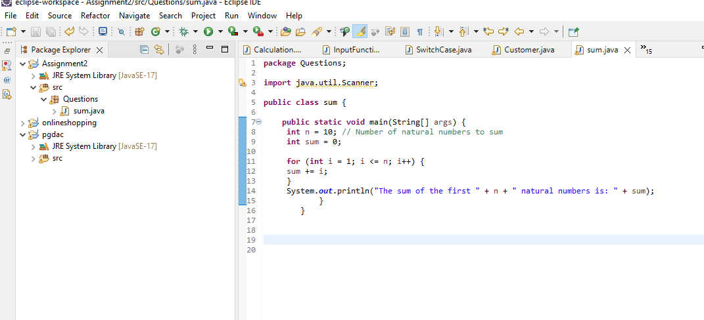

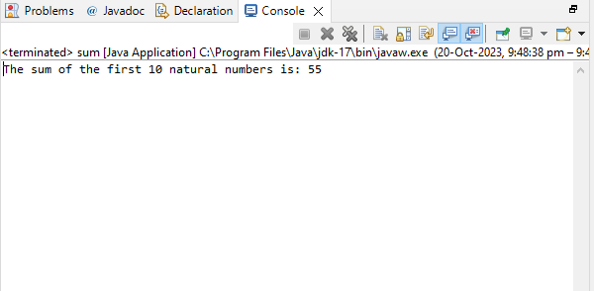

1. Write a program that prompts the user to input a positive integer. It  
   should then print the multiplication table of that number.

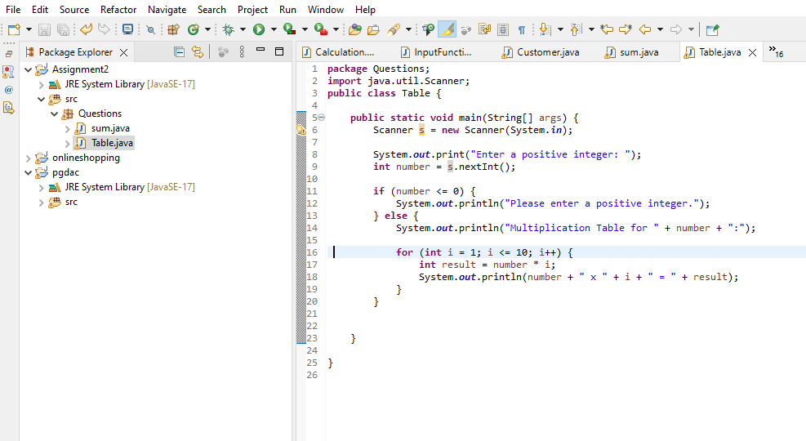

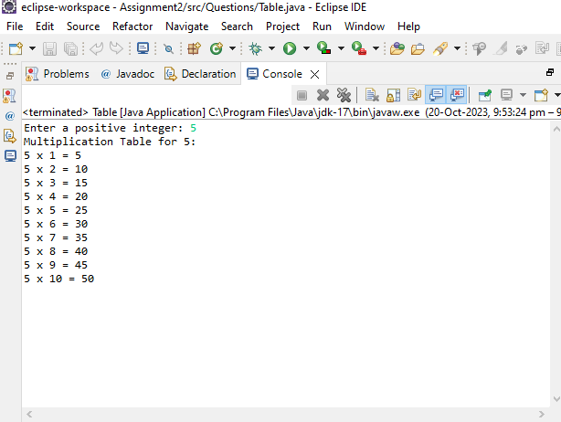

Q 3  
Write a program that prompts the user to input an integer and then  
outputs the number with the digits reversed. For example, if the input  
is 12345, the output should be 54321.

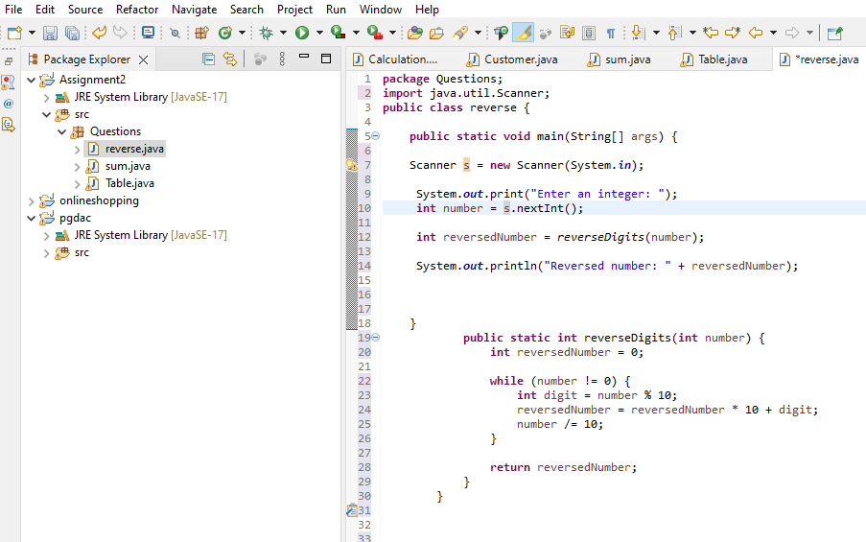

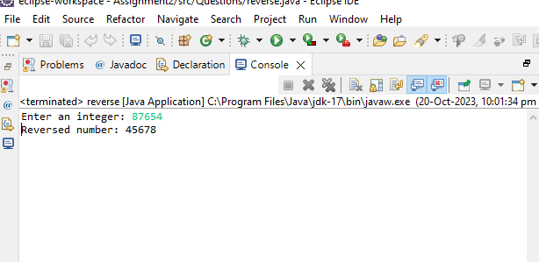

Q loop) 4 Write a do-while loop  
that asks the user to enter two numbers. The numbers should be added and  
the sum displayed. The loop should ask the user whether he or she  
wishes to perform the operation again. If so, the loop should repeat;  
otherwise it should terminate.(while loop)

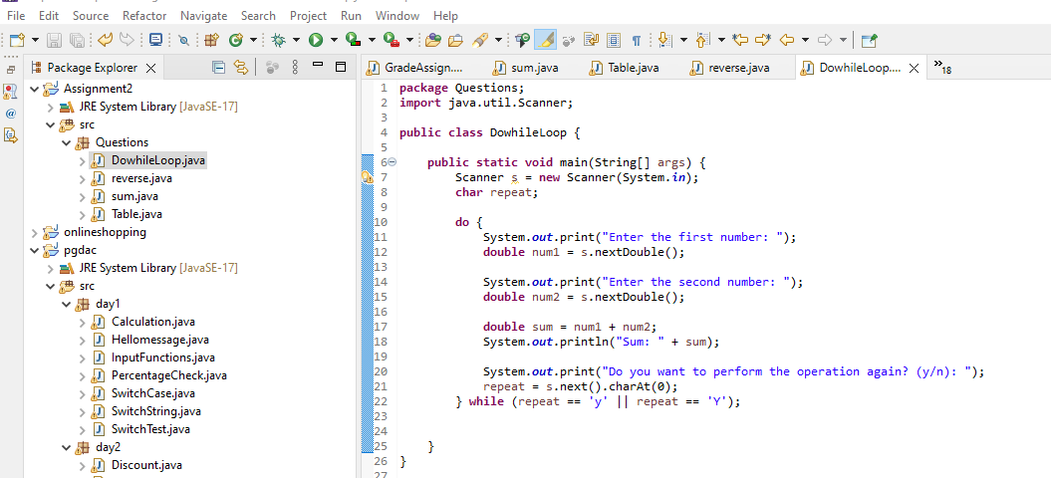

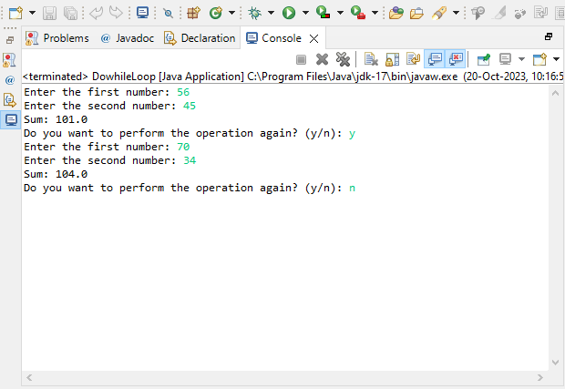  
  
Q 5 Write a program to  
print out all Armstrong numbers between 1 and 500. If sum of cubes of  
each digit of the number is equal to the number itself, then the number  
is called an Armstrong number.  
For example, 153 = ( 1 * 1 * 1 ) + ( 5 * 5 * 5 ) + ( 3 * 3 * 3 )

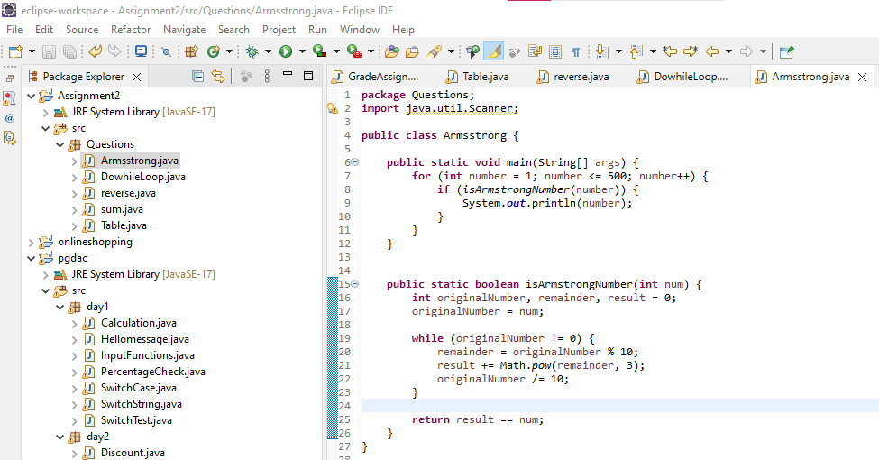

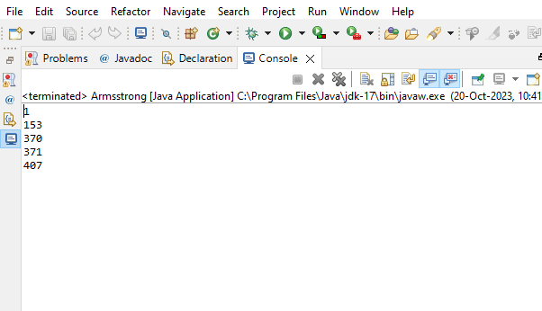

Q 6 Write a program to print Fibonacci series of n terms where n is input by user :  
0 1 1 2 3 5 8 13 24 .....

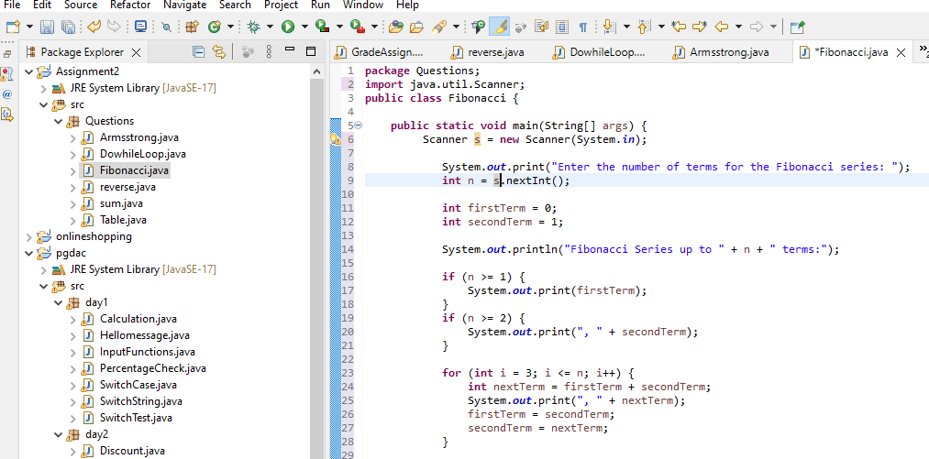

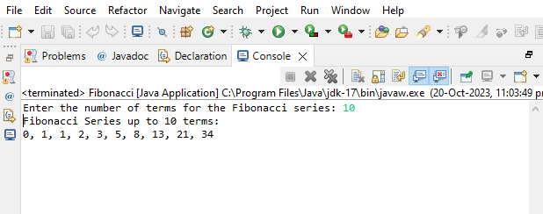

Q 7 Write a program to print following :  
  
  
  
i)  
  
**********  
**********  
**********  
**********

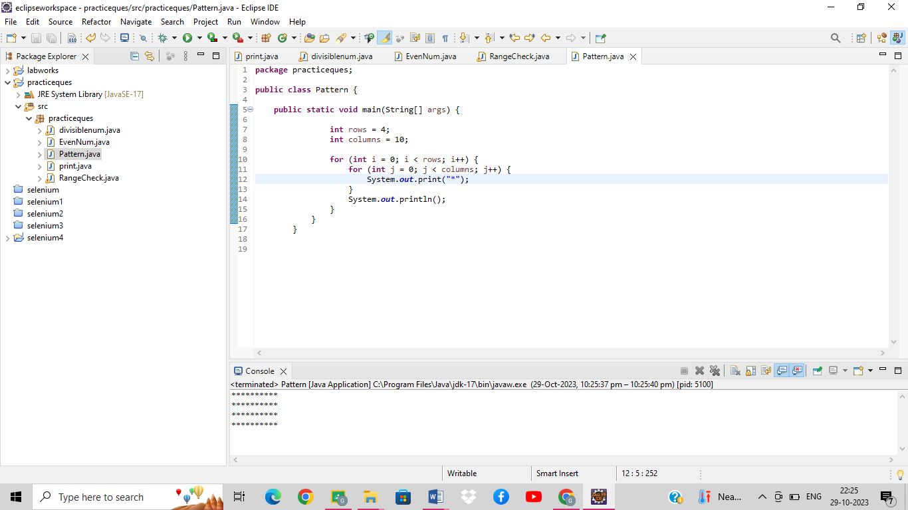  
ii)  
  
*  
**  
***  
****  
*****

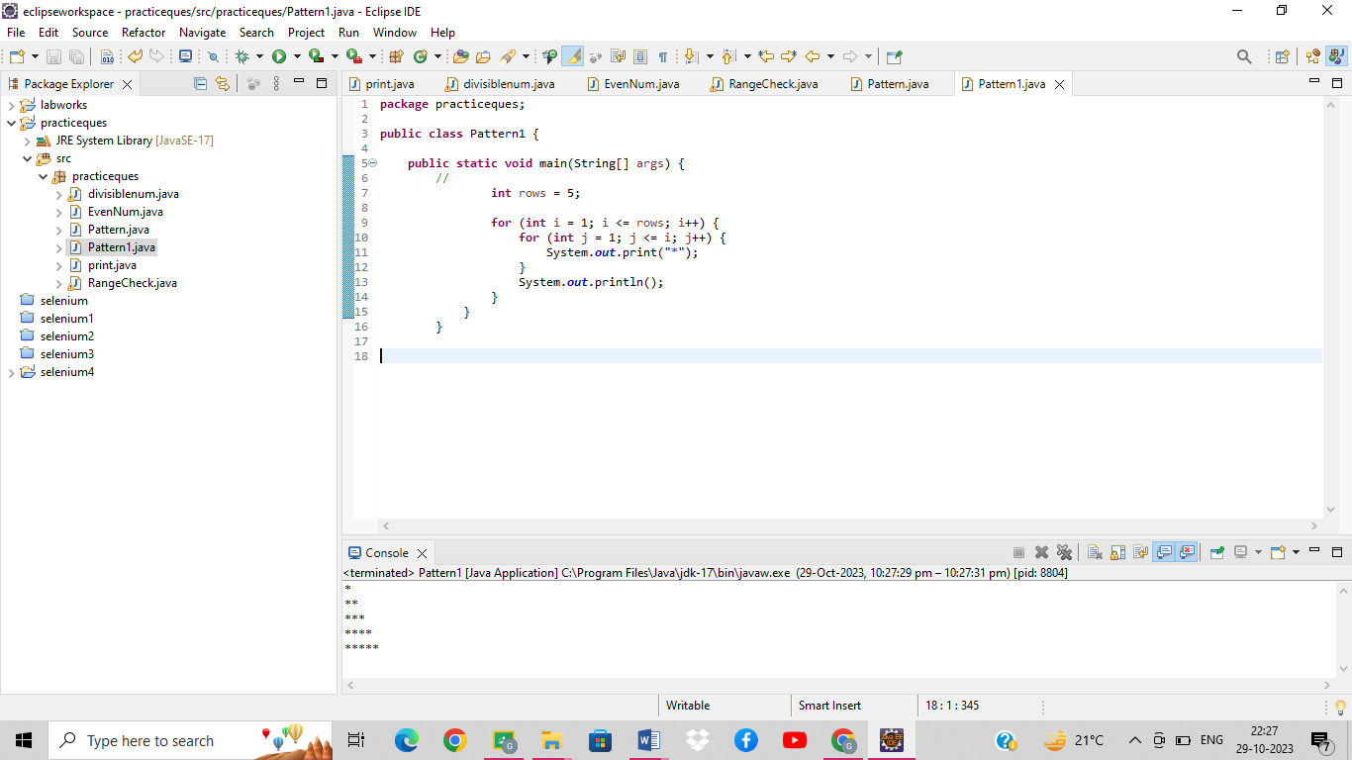  
  
iii)  
  
         *  
      *   *  
     * *     *  
  *    *    *     *

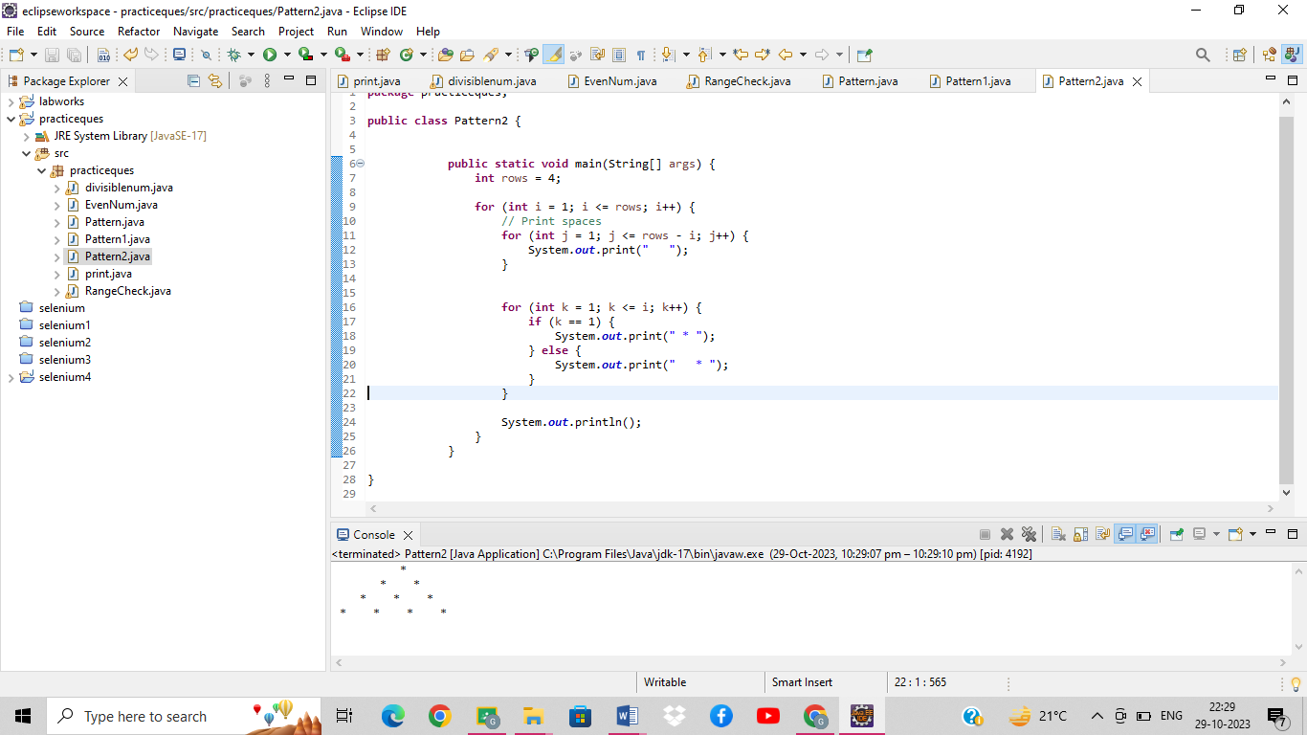  
  
  
  
iv)  
  
        *  
      ***  
    *****  
  *******  
*********

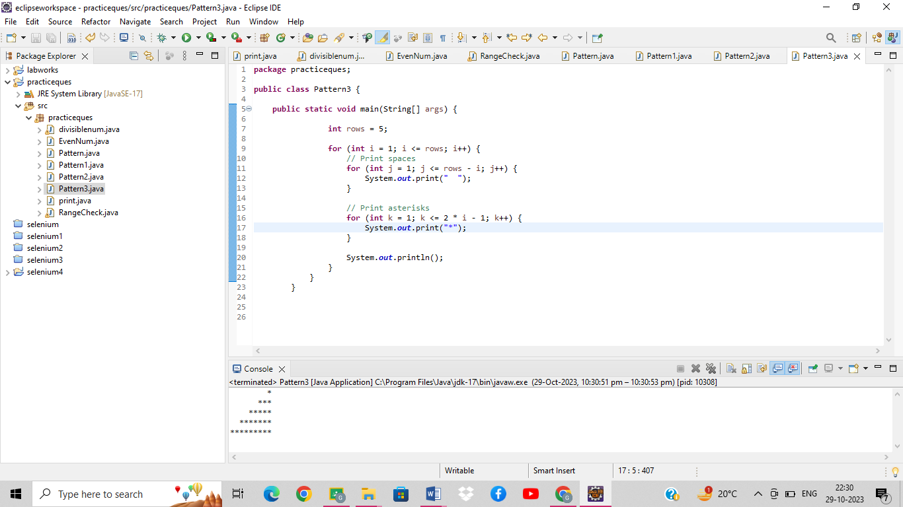  
  
v)  
  
        1  
      222  
    33333  
  4444444  
555555555

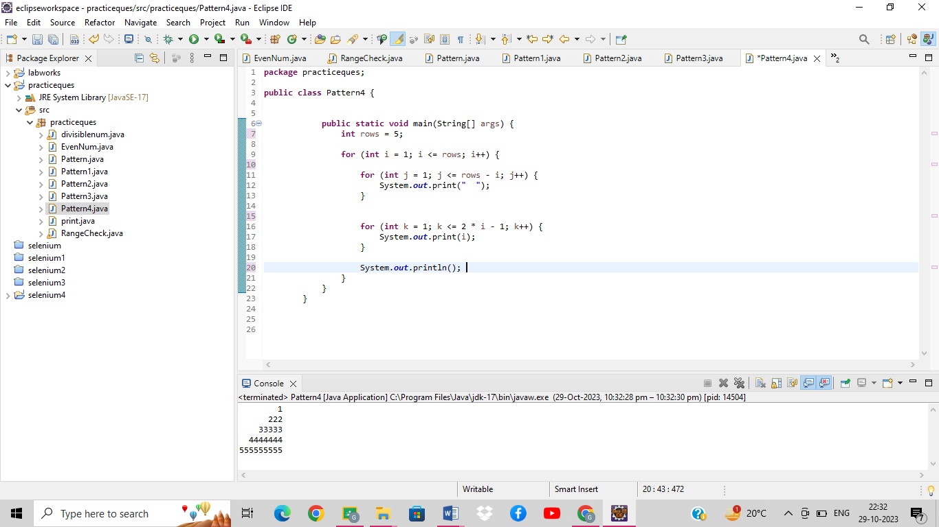  
  
vi )     ABCDEEDCBA  
         ABCD  DCBA  
         ABC      CBA  
         AB         BA  
         A             A

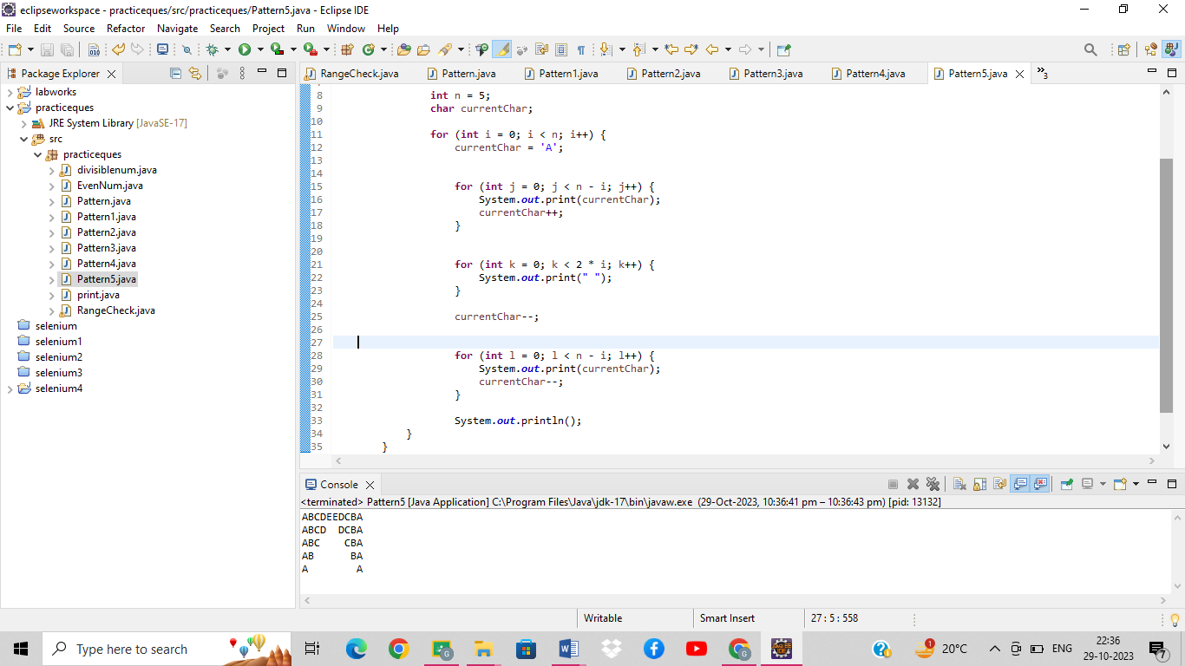  
  
  
Q 8 Write a program in java to find the sum of the even and odd digits of the number which is given as input.

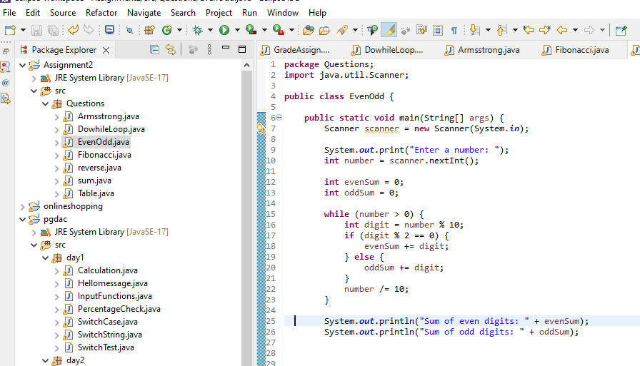

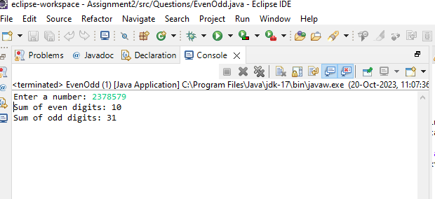  
  
Q9 Write a program to check if given number is prime or not.

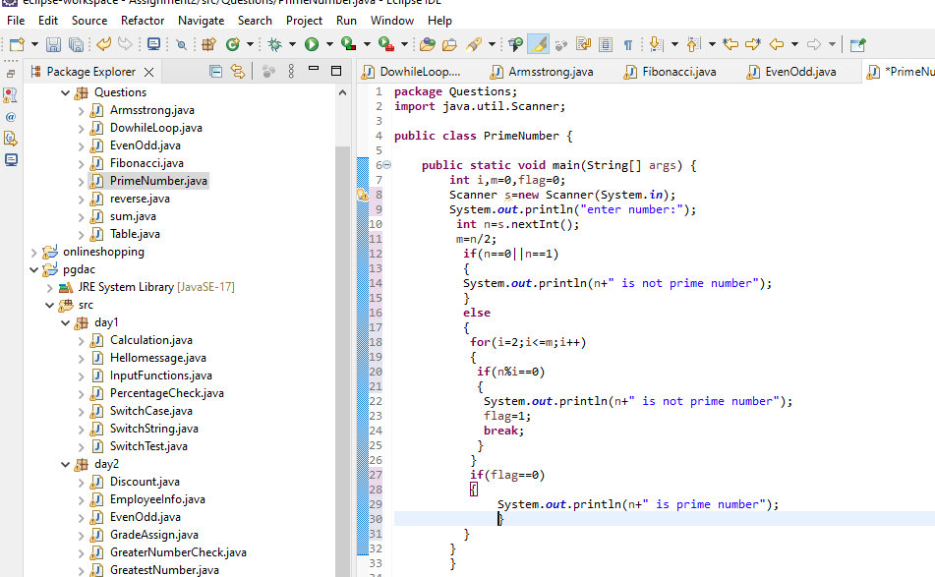

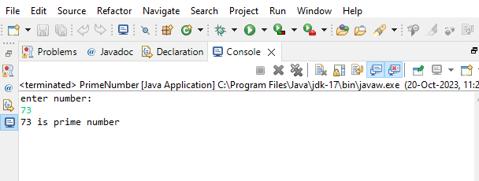

Q 10 write a program to print prime numbers between 2 to 20.

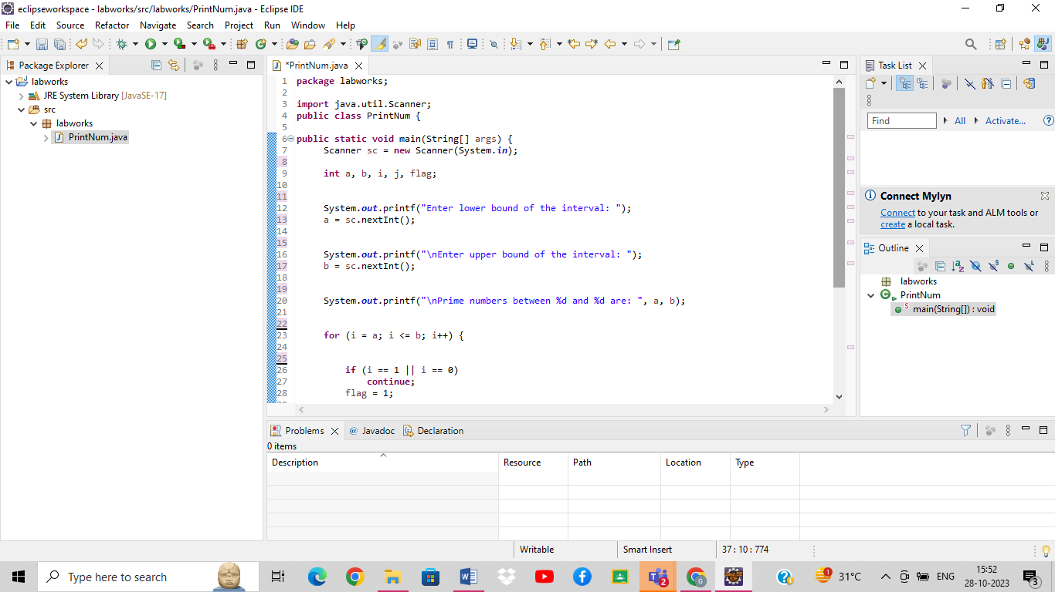

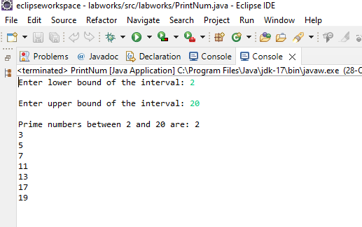

Q 11 Write program to find largest among three numbers

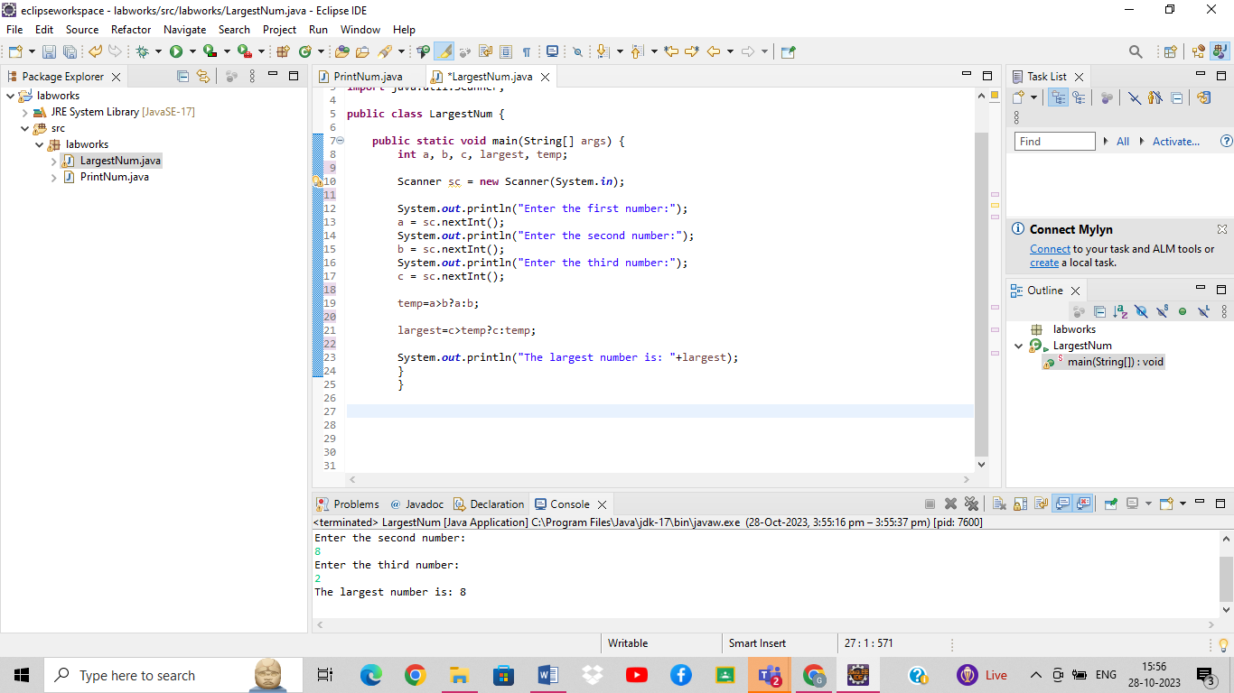  
  
Q 20 Write a program to find sum of all integers greater than 100 and less than 200 that are divisible by 7

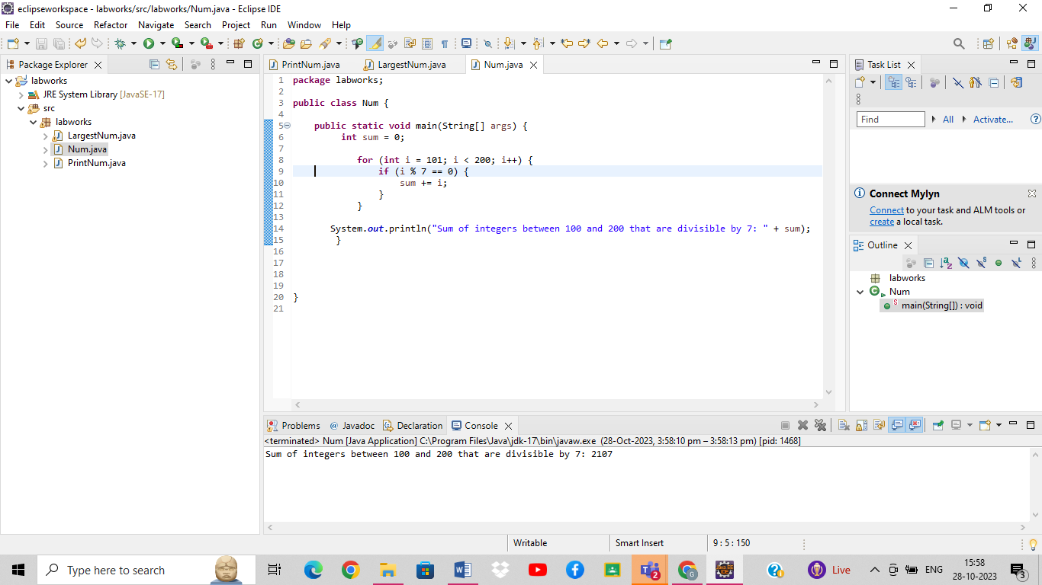  
  
Q 21 8.    Write a Java program to print numbers between 1 to 100 which are divisible by 3, 5 and by both.  
Hint  
            System.out.println("\nDivided by 3: ");          
       for (int i=1; i<100; i++) {  
           if (i%3==0)  
           System.out.print(i +", ");              
       }

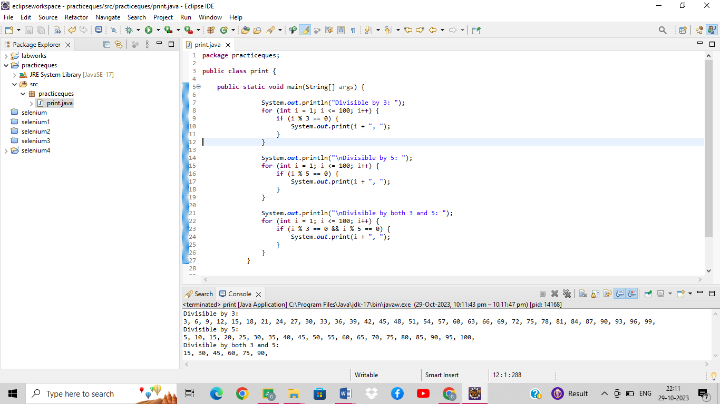

Q 22 create a menu driven application in java that show  
   "Add"        Add two number  
  "subtract"  Subtract two number  
  "Multiple"    Multiple two numbers  
  "Exit "           Exit  
  
Ask two numbers from user  and as per user choice perform necessary action using switch command

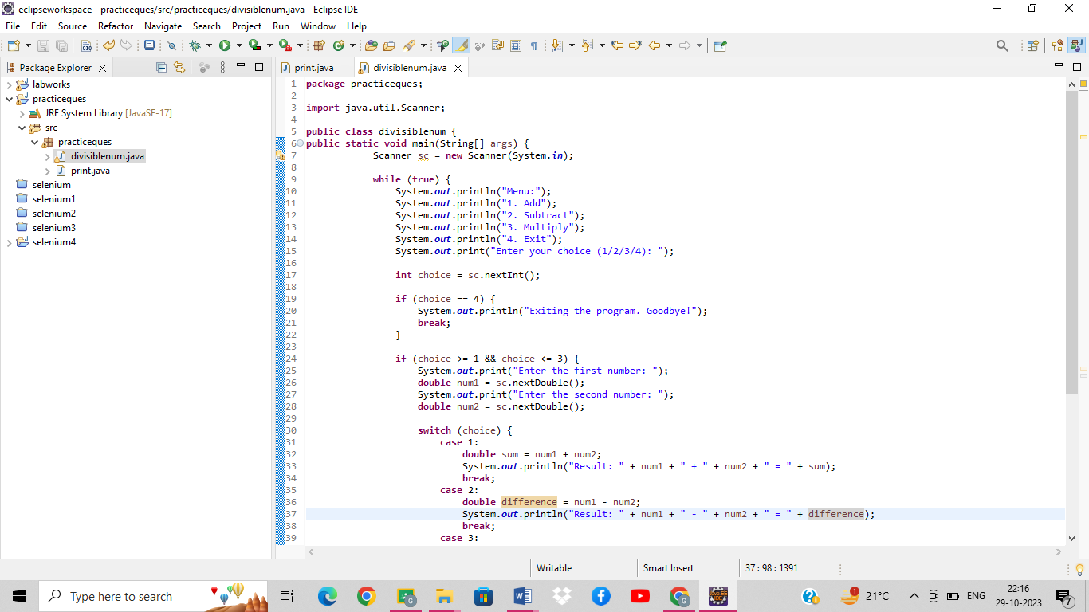

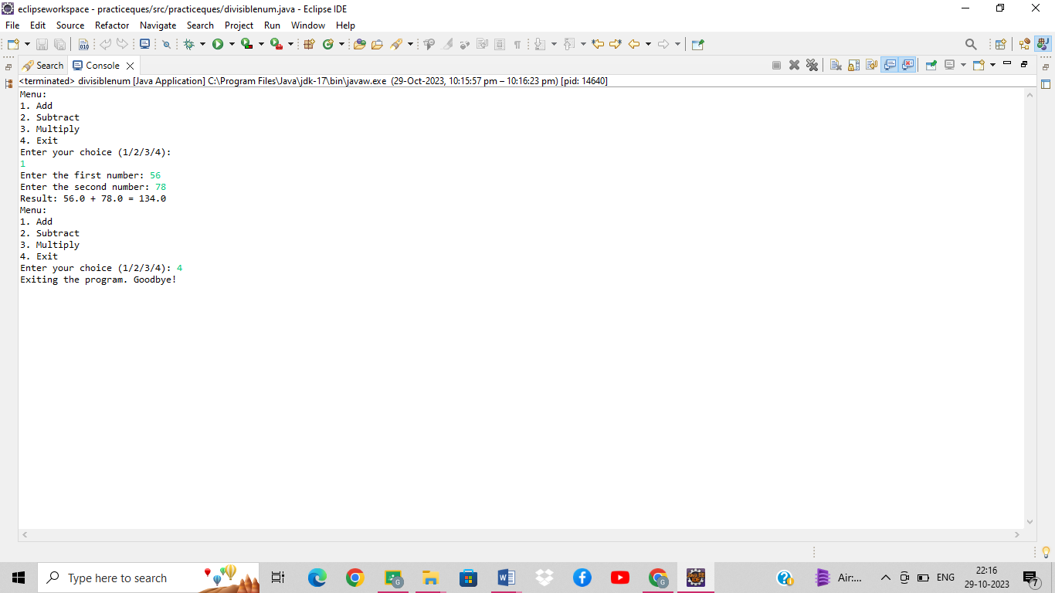  
  
Q  
23  Write a program to display first 1 to 20  even number on screen .  
Terminate the program when number 16 is found using break command .

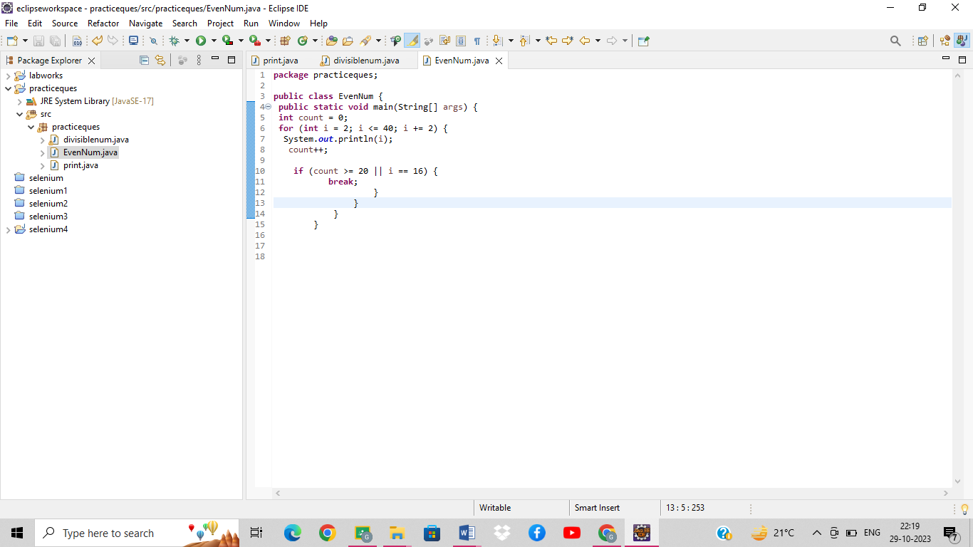

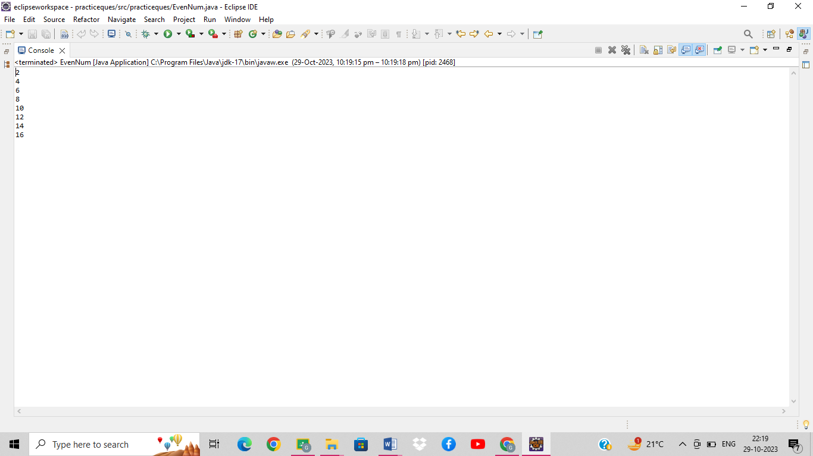  
  
Q 24 Write a Java program that accepts two double variables and test if both strictly between 0 and 1 and false otherwise.  
Hint n1 > 0 && n1 < 1 && n2 > 0 && n2 < 1  
